**Laser cooling and trapping of atoms**

In present days, it is easy to see laser beam such as laser cutting, laser swords, laser guns, laser from superman’s eyes (usually in movies),…they all have the same function: “Burn something up”.

However, laser is used not only to heat substances, but also to cool down objects (to a very low temperature). This might sound counterintuitive, but it is totally possible in our modern life.

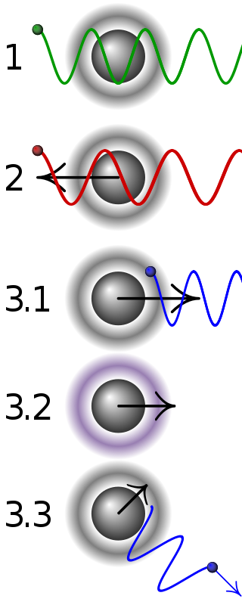***1/ Doppler cooling***

- Definition: frequency or wavelength of a wave change when obsever is moving relatively to it.

- Principle:

+ Stationery atoms does not absorb any laser.

+ Atoms move away from the laser observe red-shifted, does not absorb laser.

+ Atoms move toward the laser observe blue-shifted, absorb laser and slow down.

+ After the absorption, atoms pump to excited state.

+ Atoms emit photon in random direction, momentum remains unchanged.

- Since cooling means slowing molecules in objects, or making them stay still, this method is very common to keep the mocules “calm” in order to cool objects.

***2/ Trapping of atoms***

- Laser cooling could decrease molecular’s temperature to near absolute zero (several microkelvin), therefore no material can constrain these “ultracold” atoms, we have to trap it in another way which is known as “atoms traps”. Magnetic fields and optical fields are particularly used.

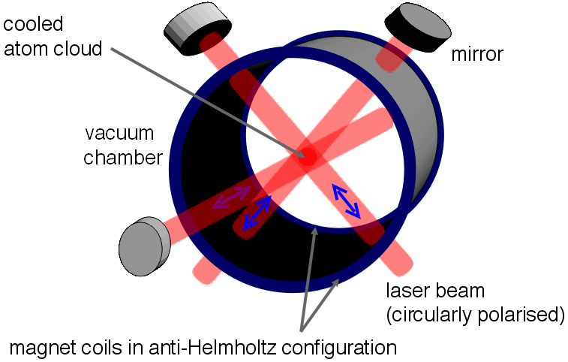- A magneto-optical trap (MOT) is a simple concept which can keep atoms in a state from every direction and cool down.

- An MOT can be created by employing 2-dimensional diffraction grating to make a configuration of laser beam from single laser.

- Small cloud near center point is where atoms are cool down and trapped.

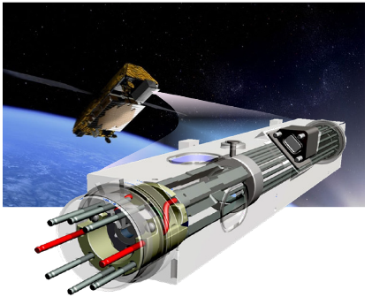3/ Laser cooling

- Laser cooling is based on Doppler cooling, but we need a specific wavelength. It is essential to tunned the laser wavelength to just longer than the still particle’s wavelength.

- Uses: macro scale object, quantum computer stuff, atomic clocks in satellites to enable the GPS.

- References:

<https://www.learner.org/courses/physics/unit/text.html?unit=5&secNum=7>

<https://www.youtube.com/watch?v=hFkiMWrA2Bc>

<https://en.wikipedia.org/wiki/Laser_cooling#Uses>

<https://www.sciencedaily.com/releases/2007/04/070406171036.htm>

- Word count: 327

- Name: Nguyễn Anh Thư

- ID: 1751023

- I affirm that I have read and understood the guidelines on plagiarism, and that this article is my own original work.

15/07/2018

Nguyễn Anh Thư